Observations on film art
http://www.davidbordwell.net/blog

Film as a narrative art

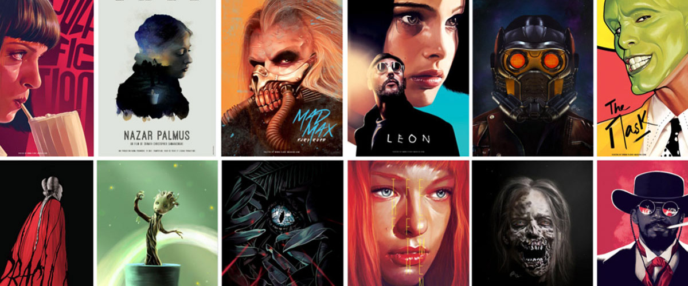
Narrative (story) is central to Hollywood cinema. Producers, directors, crew, and of course screenwriters will agree that without a good story, the movie fails.
- Indie filmmakers try to tell the stories that “haven’t been told yet.”
- Hollywood says, “We have our own stories to tell.”
- Celebrated arthouse filmmakers often focus on character as revealed through action.
- Resnais, Rivette, Fassbinder, Haneke, and many others may have told unusual stories, but still they told them.
Many viewers will say that they watch a movie to experience a story. Film critics, and the press talk about film in terms of plot. Most film study discussions on films will focus on what happens in the narrative.

Genre
Narrative is often related to the genre films. When we consider film genres, we concentrate on the narrative aspects of the film. Most genres display typical characters and plot patterns.
- The backstage musical features aging stars and young hopefuls, caught up in the process of putting on a show.
- The horror film typically centers on a monster’s attack on humans, who must fight back.
- One type of science fiction shows us an overweening scientist striving to go beyond “what is proper for humans to know.”
Historians have traced in great detail how filmmakers employed cinema as a narrative art, but we’re making more discoveries all the time.
- How have films signaled flashbacks?
- How do they let us know we’re in a character’s mind, or attached to his or her optical point of view?
- How have they structured their plots?
- Can we pick out distinct approaches to narrative–in various periods, or genres, or national cinemas?
- How have narrative conventions changed over the years?

Watch: Every Story is the same https://www.youtube.com/watch?v=LuD2Aa0zFiA

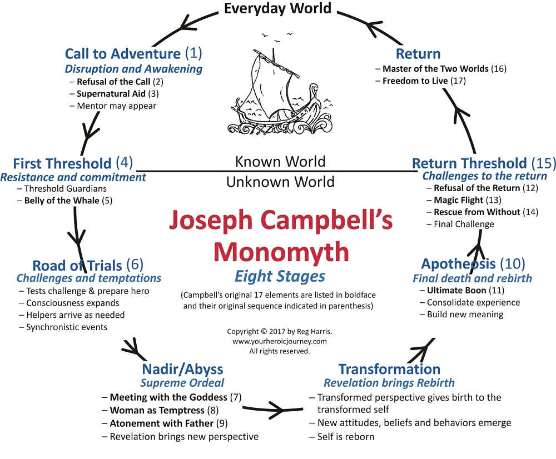

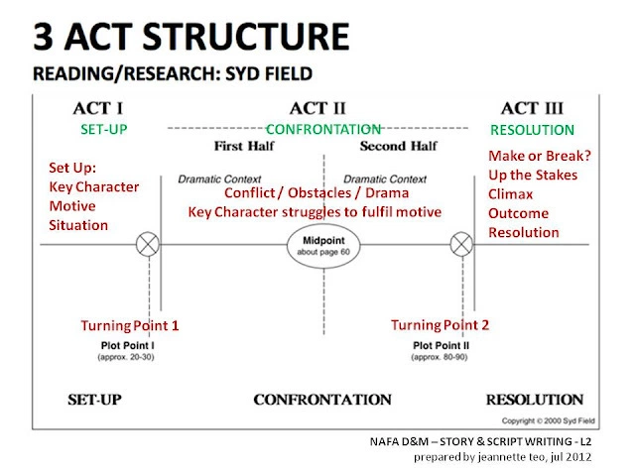

Story Structure: Super Basic Stuff
We love to tell stories, but since we live in an unnatural world, we sometimes need a little help doing what we'd naturally do.

Here we go:

- A character is in a zone of comfort
- But they want something.
- They enter an unfamiliar situation
- Adapt to it
- Get what they wanted
- Pay a heavy price for it
- Then return to their familiar situation
- They’ve changed. Usually for the better

Start thinking of as many of your favorite movies as you can, and see if they apply to this pattern. Then choose a film you’ve seen that follows this structure and fill in this chart:

Film Title:
Hero’s Journey Phases | Explanation
- Name the character who is in a zone of comfort.
2. What does the character want?

3. What is the problem/conflict/unfamiliar situation?
4. what does the character adapt to?
5. The character gets what he/she wants. What is it?
6. What is the price paid? How did the character suffer?
7. The character returns to familiar situation. Explain.
8. The character has changed.

As a film student, get used to the idea that stories follow the pattern of descent and return, diving and emerging.
See it everywhere. Realize that it's hardwired into your nervous system, and trust that in a vacuum, raised by wolves, your stories would follow this pattern.

